Subject 04 data analysis 08june2011, 13oct2011

DF=6

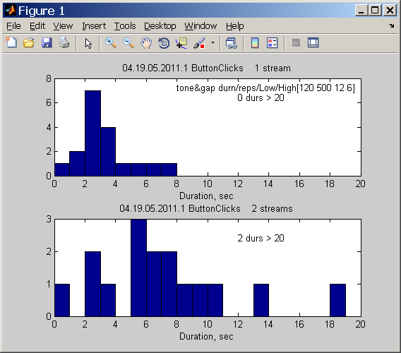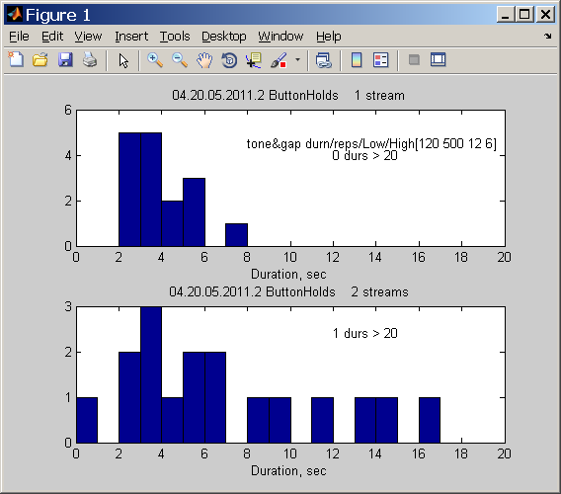

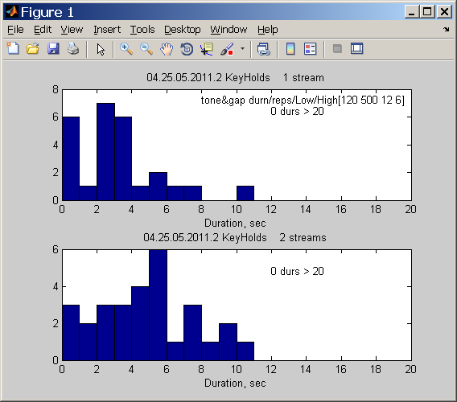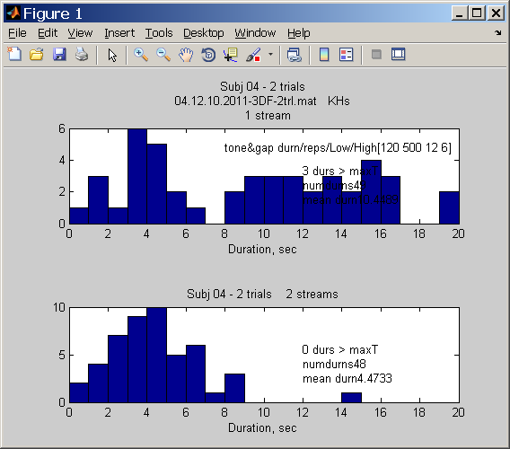these data for DF=6 in 04.12.10.2011… are superceded by data/plot just below. All 3 cond’ns and 2 trials are stored in

04.13.10.2011_3DF_2trl.mat . JR redid this case DF=6. NOTE: subj 04 reported post-run that there were some patterns sounding not like 2-streams or HLH_HLH… triplet but rather like doublets: LH_LH_LH_ …

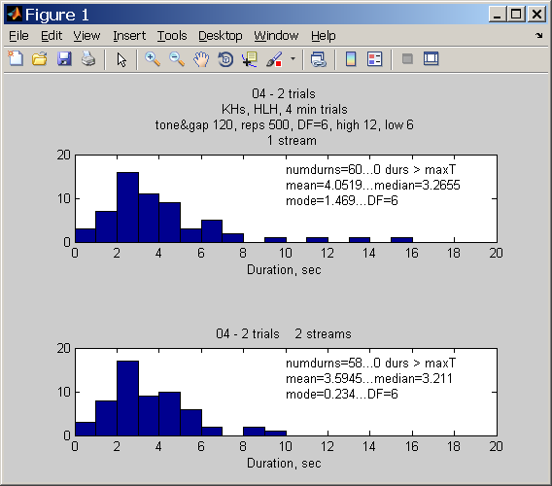

DF=5

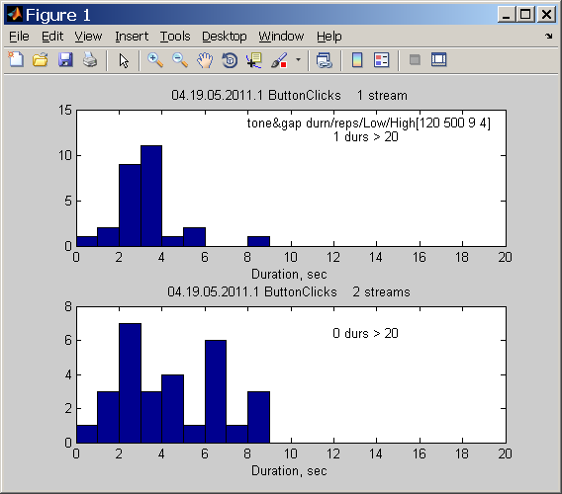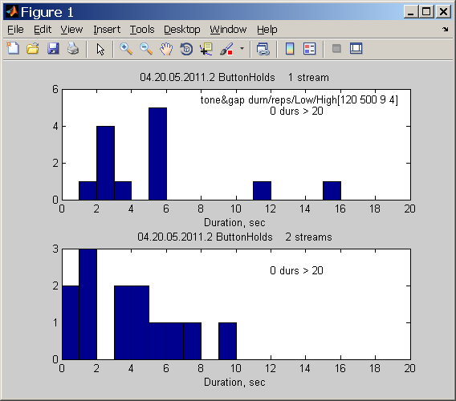

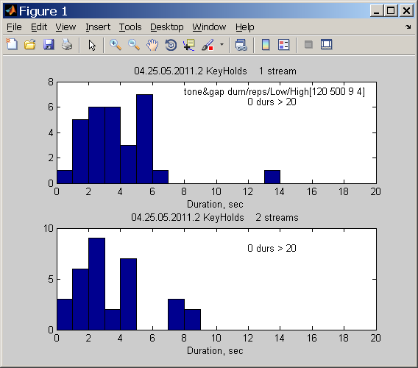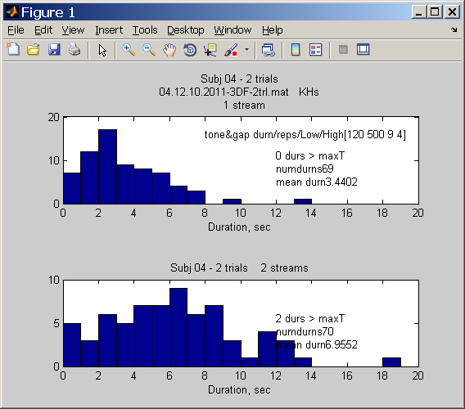

DF=4

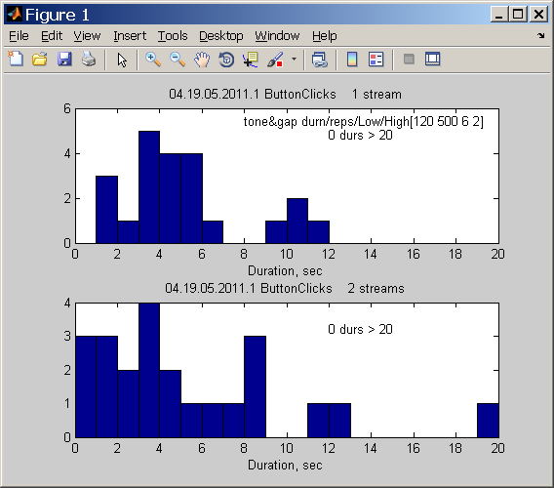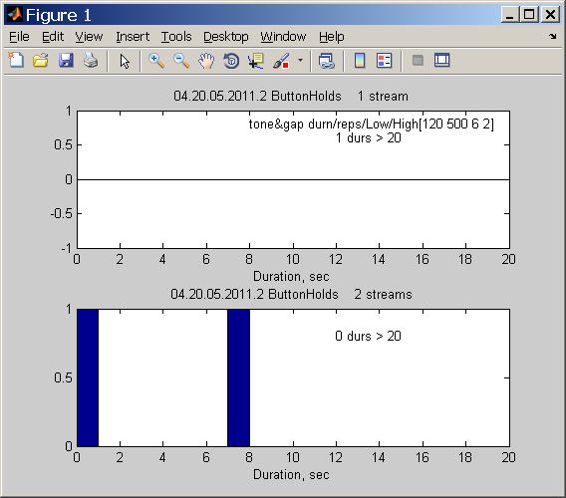

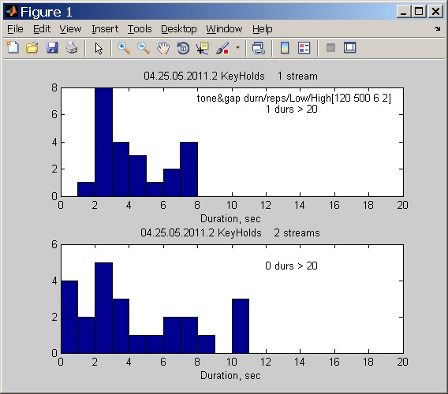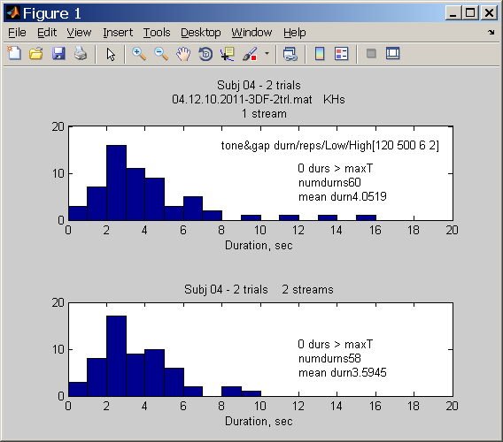

Subject 04 data analysis 08june2011

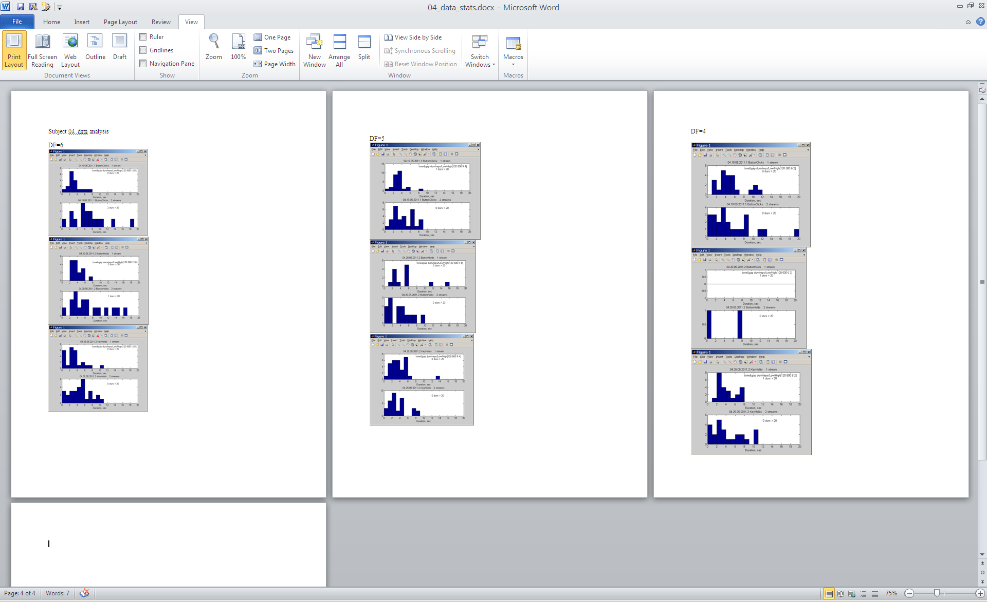

Summary data for 3 trials from

04.25.05.2011.2.mat and from 04.13.10.2011_3DF_2trl.mat

Combined in

Rnet04.mat

DF=3 3 trials.

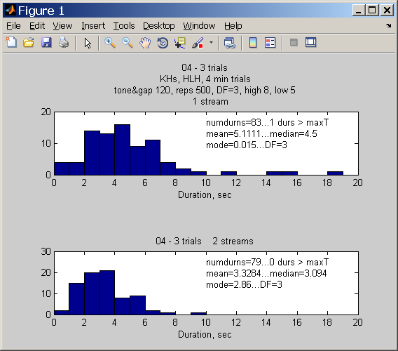

Stats for --04 - 3 trials...DF=3

83.0000 5.1111 4.5000 0.0150

79.0000 3.3284 3.0940 2.8600

DF=4 3 trials.

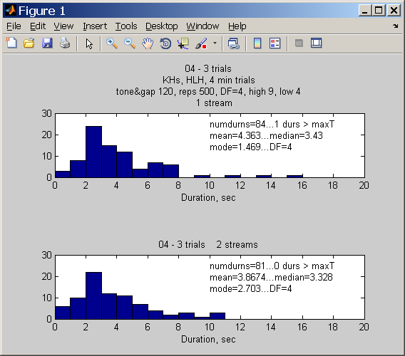

Stats for --04 - 3 trials...DF=4

84.0000 4.3630 3.4300 1.4690

81.0000 3.8674 3.3280 2.7030

DF=5. 3 trials.

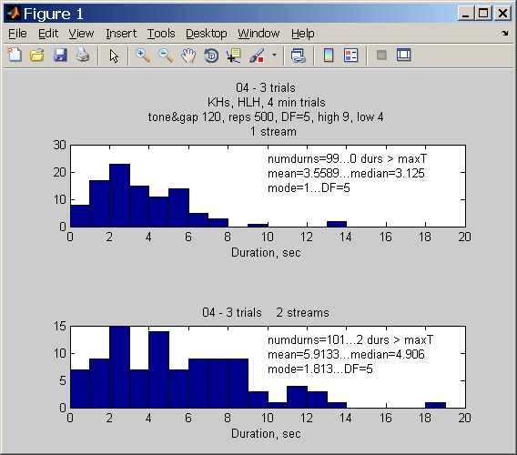

Stats for --04 - 3 trials...DF=5

99.0000 3.5589 3.1250 1.0000

101.0000 5.9133 4.9060 1.8130

DF=6. 3 trials.

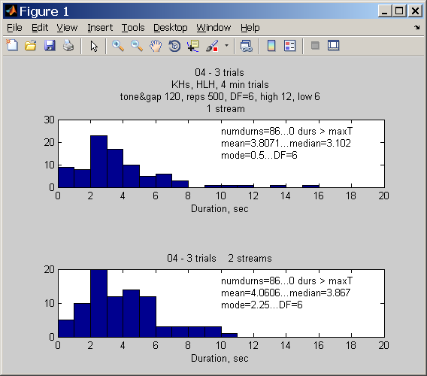

Stats for subj: 04 - 3 trials...DF=6

86.0000 3.8071 3.1020 0.5000

86.0000 4.0606 3.8670 2.2500

DF=7, 3 trials.

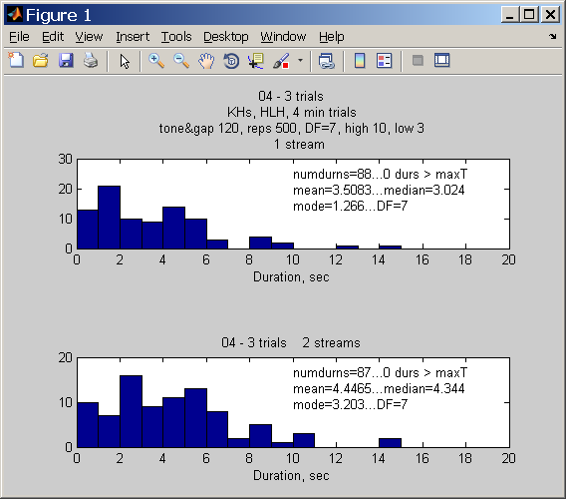

Stats for --04 - 3 trials...DF=7

88.0000 3.5083 3.0240 1.2660

87.0000 4.4465 4.3440 3.2030